Strait Talk Symposium 2017 Application
United States of America
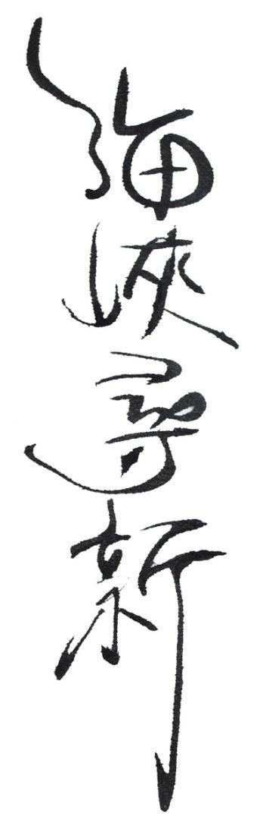
Brown University, Fall 2017
Time: Oct 19th to Oct 26th
Thank you for your interest in the Strait Talk Symposium.
Strait Talk is a non-partisan dialogue program that seeks to transform international conflict by connecting young people from both sides of the Taiwan Strait and the United States and empowering them to strive for peace. We are looking for students and/or young professionals from the U.S. (ages 18-35) who demonstrate interest in and commitment to peace-building across the Taiwan Strait. During the symposium, delegates will participate in Interactive Conflict Resolution (ICR), an intensive process that requires a full 40 hours of constant engagement and sensitivity. Thus, qualities we find essential in applicants include the ability to listen actively and respectfully, open-mindedness, and the capacity to navigate social dynamics through constructive dialogue. In addition, you must be able to speak fluent English. Other assets we value are excellent verbal and communication skills and in-depth knowledge of the history of the conflict.
Applications are due August 20th, 2017 11:59 Eastern Standard time. Please e-mail completed applications to straittalkus@gmail.com. Since applications are accepted on a rolling basis, you should apply as early as possible. If you have any questions or concerns, feel free to email straittalkus@gmail.com. Please note that you may be interviewed online as part of the application process.
Please answer all of the following questions in English and respond honestly. In addition, please attach a copy of your Resume/Curriculum Vitae. Your application will be evaluated based on your academic and personal experiences as well as on the quality of your essays. Please make sure to read all of the information provided on our website (www.straittalkbrown.com) before applying.
An important aspect of Strait Talk is that the delegations contribute different perspectives to the dialogue, so we ask that you apply to the delegation with which you identify the most. If you are an international student from China or Taiwan studying in a university in the US, we encourage you to apply to the delegations from your respective homes instead.
All information provided on this application will be kept confidential.

BIOGRAPHICAL INFORMATION
NAME: ___________________________________ CHINESE NAME: __________________________
GENDER: _____ AGE: _____ PHONE #: _______________ EMAIL: ________________________
SKYPE: _______________ ADDRESS: ___________________________________________________
CURRENT UNIVERSITY (or university attended): _________________________ GPA: ____________
YEAR OF GRADUATION (or expected): ___________ MAJOR: _______________________________
CITIZENSHIP: ____________________ PASSPORT NUMBER: ________________________________
Have you ever traveled to Taiwan or China? If so, which one? _____________________________________

____________________________________________________________________________________________
How did you hear about Strait Talk?
_______________________________________________________________________________________

_______________________________________________________________________________________

_______________________________________________________________________________________

_______________________________________________________________________________________

ADDITIONAL QUESTIONS
- Why do you want to participate in the symposium? What new experiences and insights do you hope to obtain through this opportunity? (300 words or less)
- What is your understanding of the nuances between being Chinese or Taiwanese? How do you view those who are ethnically Chinese but are citizens of countries outside Mainland China? (250 words or less)
- Please choose two historical/political events (one that took place before the year 2000, and one after 2000) that you consider crucial in shaping current cross-strait relationship. Elaborate on your choices. Good answers will analyze, rather than summarize. (350 words or less)
4 Please describe a previous experience/incidence in which you needed to utilize skills of leadership and team-collaboration to solve a conflict. How did you go about the issue, and what did you learn from it that you think you can apply during ST? (300 words or less)

- Please feel free to add any additional information about yourself, in English, which you feel we should know in evaluating your application. This section is optional. Please do not repeat any information that has already been covered in the rest of the application.

SIGNATURE
I affirm that the above information that I have provided in this application is a correct and accurate reflection of my academic and scholastic accomplishments. I have filled out this application as honestly as possible. I understand that if I am found to have reported false information, I will be ineligible to attend Strait Talk.
Electronic Signature: _________________________ Date (MM/DD/YYYY): _________________________

Please send completed applications to straittalkus@gmail.com by August 1st, 2017 11:59 PM EST.
Congratulations, you are done! Thank you for taking the time to apply - we look forward to getting to know you.

